Room 2 Question 1
Perforated Duodenal Ulcer
Stem: A 58-year-old woman presents to the emergency department (ED) with a 1-hour history of generalized abdominal pain that began abruptly and now radiates to both shoulders. The patient has a prior history of peptic ulcer disease but is not currently on acid suppression therapy, and she is on oral steroids for a skin condition. No prior abdominal surgery. Does not smoke tobacco or drink alcohol.
ED physician calls you and tells you a CT Abdomen is ordered, vitals: Temperature is 36.5°C, heart rate is 100 bpm, blood pressure is 125/70 mm Hg, and her abdomen is diffusely tender to palpation, labs are processing.

Anything else you want to order?
- Upright chest x-ray or an abdominal x-ray.
You go to see the patient; X-ray technician just finished the xray you requested?
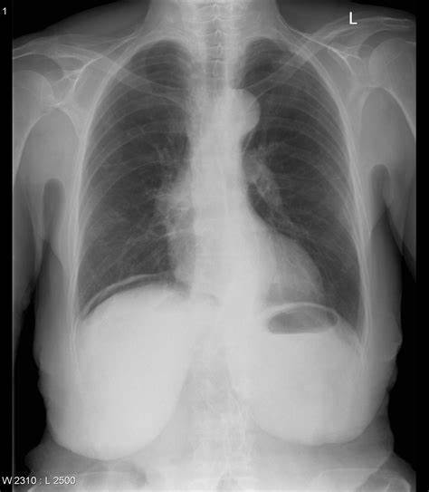

Transport is waiting to take the patient to CT, while you are blood pressure is 90/55 HR 126 RR 21.She is quite but uncomfortable appearing. What would you like to do ?
- Resuscitation: IVF, Antibiotics, Foley catheter, NG tube.
- OR for exploratory laparotomy.
On exploration, you identify a 1 cm anterior duodenal perforation. How would you address that?
Omental patch.
Patient recovers and get discharged, 18 months later she shows up in your clinic with GERD symptoms, despite being on PPIs, you decided to do EGD describe?
- Procedural sedation
- Place in left lateral decubitus position.
- Insert scope into mouth under direct visualization.
- Pass the scope past the cricoarytenoid cartilage into the esophagus.
- Ensuring direct visualization, pass the scope through the esophagus with continuous insufflation in order to visualize the entire esophagus.
- Visualize the gastroesophageal junction and pass into the stomach.

Scenario: Your patient is 52 Y M, prior history of PUD who tells you symptoms had been refractory, patient vitals are within normal range, when you proceed to OR you encounter only minimal contamination, would you consider anything different for this patient?
- Definitive ulcer procedure.
Describe one?
- Truncal vagotomy and pyloroplasty.
  - Isolate the distal esophagus.
  - Identify, dissect, and transect the vagal trunks—send nerve biopsy to pathology.
  - Dissect the distal 6-cm of the esophagus to ensure complete division of vagal fibers.
  - Mobilize the duodenum.
  - Make a longitudinal incision from the antrum onto the proximal duodenum.
  - Place stay sutures at either end of the incision to facilitate transverse closure.
- Antrectomy
  - Free the greater curvature of the stomach.
  - Dissect the first part of the duodenum from the pancreas.
  - Divide the stomach.
  - Ligate the right gastric artery at the level of the pylorus
  - Divide the duodenum just distal to the pylorus—send duodenal stump margin for pathology.
  - Complete with either a Billroth I or Billroth II anastomosis.
- Parietal Cell Vagotomy.
  - Divide the lesser omentum from the lesser curvature.
  - Encircle the trunks with Penrose drain and apply tension to facilitate exposure of branches.
  - Dissect and ligate neurovascular branches of the vagal trunks proximal to the crow’s foot of the nerve of Latarjet
  - Skeletonize the distal 6 cm of the esophagus to ensure complete division of criminal nerve of Grassi.

Room 2 Question 2

Anal Cancer
Stem: 70-year-old male presents with 1 month history of anal pain and bright red blood per rectum. He reports no prior history of hemorrhoids, STD’s, ano-receptive intercourse or personal or family history of colorectal cancer. Digital rectal exam reveals a mass in the anal canal. Anoscope reveals a 3 cm ulcerated mass in the posterior anal canal. Inguinal lymph node exam is negative.

What is your Differential Diagnosis?
Condyloma
Squamous cell cancer
Adenocarcinoma
Melanoma
What Additional Workup or Studies?
- Rectal exam: Identify size and location of the mass in anal canal or anal margin.
- Colonoscopy – no other abnormalities
- CEA - WNL
- Biopsy the mass
- Stage: CT Chest + MRI or CT of abdomen/pelvis + PET CT for clinical N and M staging – No metastases
Define T classification of SCC of anus?
    - Tis = anal intraepithelial neoplasia
    - T1= <2cm
    - T2= 2-5cm
    - T3= >5cm

Scenario 1: Biopsy reveals Squamous cell cancer: How would you treat?
- Nigro protocol
  - What is the Nigro Protocol?: (5-Fluorouracil + mitomycin + RT) for all stages except metastatic disease – other systemic chemo
When would you re-examine / follow up the patient?
Follow up exam in 8-12 weeks
What if positive for tumor? => Repeat f/u at 6 months

What would you do for positive inguinal nodes on presentation? = Boost radiation to inguinal nodal basins.

When would you consider surgery? What kind of surgery?
a. APR if Nigro protocol fails or progression of tumor.
b. Wide local excision sometime considered with lesions <1cm if able to spare sphincters
Scenario 2: Biopsy reveals adenocarcinoma: (Note to examiner, treated like rectal cancer)
- MRI pelvis (superior to endoscopic US)
- CT chest/abdomen/pelvis for N/M staging.
- Treatment is usually total neoadjuvant therapy (including chemoradiotherapy) – (Not Nigro Protocol)

Pitfalls:
- Lack of knowledge about the Nigro protocol
- Proceeding to APR or biopsy if tumor still positive at 08-12 weeks.
- Inguinal LN dissection instead of radiation.
- Offering Nigro protocol for Adenocarcinoma of the anus.

Room 2 Question 3

Ventilator Assosciated Pneumonia
Stem: A 28-year-old male sustained a significant traumatic brain injury (Glasgow Coma Scale of 8) after MVC, was intubated at site. Subsequent workup revealed multiple cerebral contusions. He was then admitted to the ICU and was managed with supportive care. On the 4th day following trauma, he mounted a febrile response to 101°F, had a new onset infiltrate in the right upper lobe, and developed leukocytosis.

What is Your Differential Diagnosis?
- VAP (Ventilator associated pneumonia)
- Pneumonitis.
- Pulmonary contusion.
- PE.
- ETT migration.
- Mucus plug
What would you like to do now?
- Antipyretics.
- ABG.
- Labs: WBC 16000
- CXR: Previously seen infiltrate, dense, ETT 4 cm above the carina.
- Bronchoscopy and quantitative bacteriology. (Sputum Gram stains or cultures are considered inappropriate as they are neither sensitive nor specific. The specimen used for quantitative bacteriology should be obtained either through a bronchoscope or by the use of a coaxial catheter called the mini-BAL)
Describe how to perform Bronchoscopy?
- Introduced the bronchoscope through an endotracheal tube.
- Advance to the level of the vocal cords.
- Careful inspection of the entire airway is performed.
- Effort should be made to avoid unnecessary contact with the mucosa to avoid trauma.
- Collect specimens.
- Final assessment of the airway should be performed ensure adequate hemostasis.
- A post-procedural chest x-ray
Patient started requiring higher FiO2 and PEEP, suction aspirate are mucopurulent , what would you like to do?
- Start vancomycin and Cefepime for VAP. (high risk of MRSA in ICU patients) until the quantitative cultures results.

